

COM 2610 Data into Graphics: 100 pts
DO NOT USE Data Tables for this Assignment!
For #1 and 2 research numeric information and accurately present it visually in 2 informational graphics. Refer to Ch. 7 of the textbook, to analyze the data and choose the proper graphic type. Read the rubric, page 2, so you understand what you are being graded on.

Submit your graphics in a WORD document—NOT in Excel spreadsheets.
# 1 – Compare the Fall enrollment (of the previous year) for 4 Colorado higher educational institutions.

# 2 – Compare the tuition (15 hours) for the same 4 Colorado higher educational institutions for the same year.
NOTE: Graph the data provided below for Problems 3 and 4.
# 3 – Using the age demographic information provided create a graphic showing the MSU Denver’s student body breakdown by age range. Remember also display the percentages.

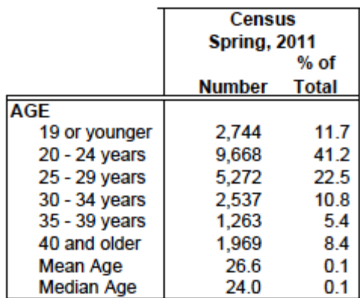

# 4 - Using the Census Table below show the trends of full and part-time students over the 5-year period at MSU Denver. Remember to also display the numbers and percentages. All the relevant data including average hours registered should be included in ONE graphic.
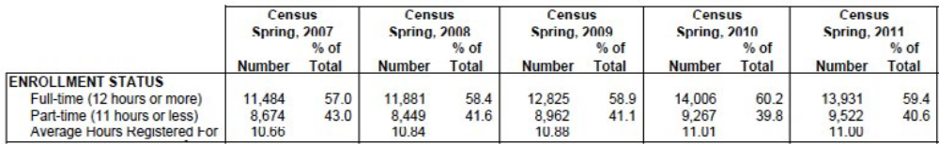

Grading Criteria
 | Strong | Developing | Needs Work | Missing
 | 20 Points | 15 Points | 5 Points | 0 Points
Presentation
Quantity of graphics | Four information graphics produced. | Three information graphics produced. | Two or fewer graphics produced. | Element missing.
Analysis & Presentation
Graphic Format | The correct format was selected for all four of the graphics. | The correct format was selected for three of the graphics. | The correct format was selected for two of the graphics. | Element missing.
Accuracy | The data (numbers) and percentages are presented accurately and labeled in all four of the graphics. | The data (numbers) and percentages are presented accurately in three of the graphics. | The data (numbers) and percentages are presented accurately in two of the graphics. | Element missing.
Color | The colors are aesthetically pleasing and add to the presentation of info. | The colors are acceptable, but do not add to the presentation. | The colors distract from the presentation of information. | Element missing.
Type Labels | All graphics are labeled; labels are easy to read and error-free. Graphics include: Title, Figure, Source, Percentages and Data points. | Three graphic labels are accurate and easy to read OR error-free. | Less than three information graphic labels are accurate, or the graphics are poorly labeled. | Element missing.

